RANGKUMAN BAHASA INGGRIS

BAB I

THE LIBRARY IS OVER THERE

1. **THINGS IN SCHOOL**

Look at the pictures. Listen to your teacher telling you the name of each.

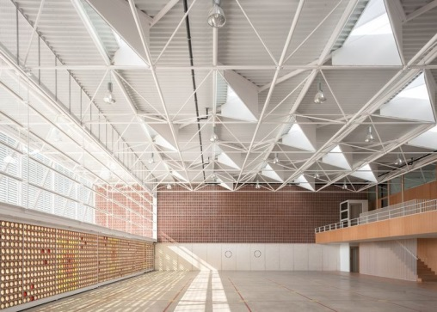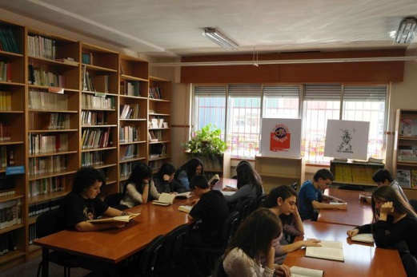

**Hall Library**

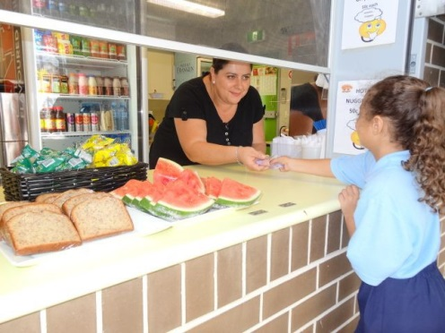 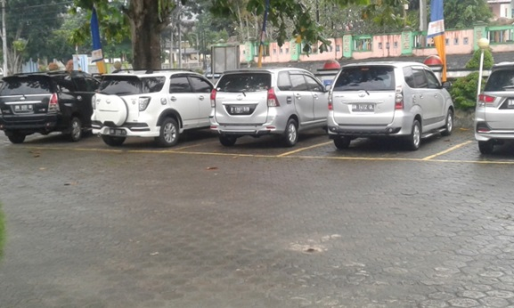

**Canteen Parking Lot**

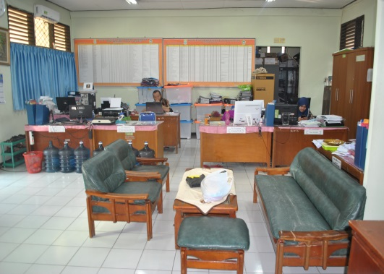 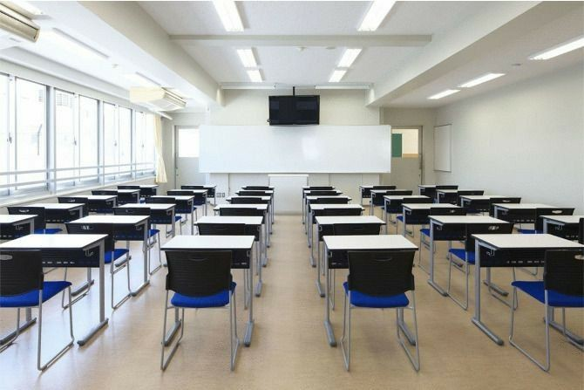

**Teacher’s Room Class Room**

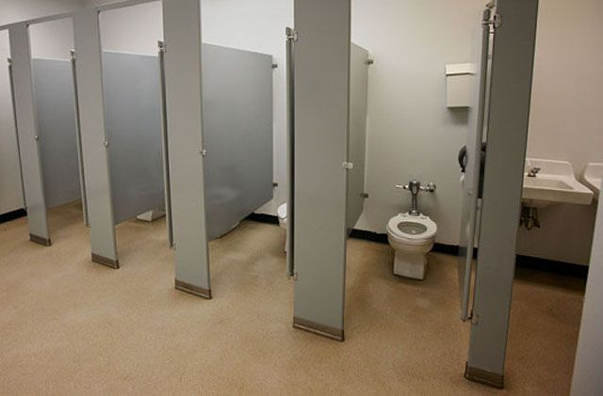 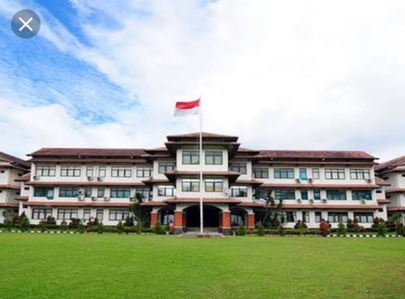

**Restroom School Yard**

We will tell the names of the things at the school, and their locations.

Here are what we will do:

* First, we will watch video our school to identify the rooms and other facilities there
* Second, we will use a dictionary to know their names.
* Then, we will plan what to say about each of our findings in our notebooks, like the examples.
* Finally, we will report all our findings orally to the class.

We will use a dictionary. We will spell the words and use the punctuation marks correctly. We will also say each word loudly, clearly, and correctly. If we have any problems, we will go to our teacher for help.

**Vocabulary list :**

1. We = kami/kita
2. Will = akan
3. Tell = menceritakan/memberitahu
4. Thing =barang/benda
5. School = sekolah
6. Number = angka/jumlah
7. Location = lokasi/letak/tempat
8. First = pertama
9. Go = pergi
10. Around = sekitar
11. Identify = mengenali
12. Room = ruangan
13. Other = lainnya/lain-lain
14. Facilieties = fasilitas/perlengkapan
15. Second = kedua
16. Dictionary = kamus
17. Know = mengetahui
18. Then = kemudian
19. Say = bicara
20. About = tentang
21. Find = temukan
22. Notebook = buku catatan
23. Example = contoh
24. **The School Map**

**Look at the map and the place in the school!**

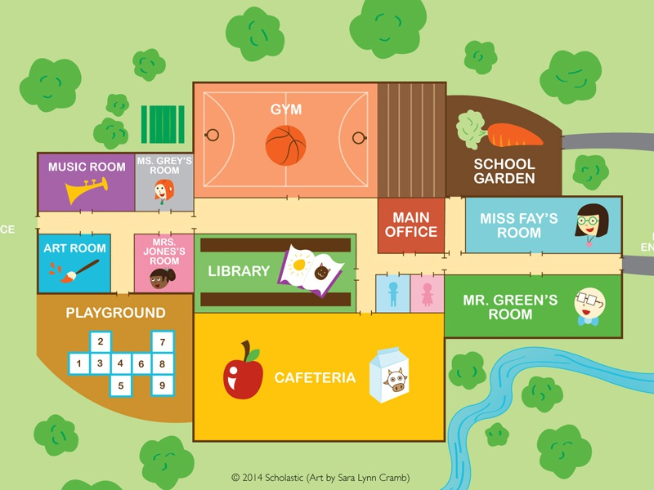

**SCHOOL YARD**

**VEGETABLE GARDEN**

**CANTEEN**

**CLASS ROOM**

**CLASS ROOM**

**CLASSROM**

**CLASSROM**

**Note :**

1. Music room : you play instruments in this place
2. Restroom : you wash your face and hand in this palce
3. Class room : you study and have fun in this place
4. Canteen : you aet a snack in this place
5. Playground : you play with friends in this place
6. Art room : you paint in this place
7. Vegetable garden : you grow vegetables in this place
8. Library : you read book in this place
9. School yard : you play sports in this place